Introduction:

The problem that was to be solved was to come up with linked list sorting algorithms.

Solution:

I first attempted at the problem by writing pseudocode and trying to make sense of it. I then implemented it into code and ran several times. Each time I ran it I got close to solving the problem. I finally followed it up with actually coming up with the solution.

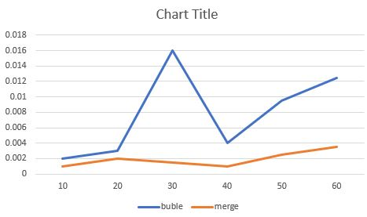 Results:

The experiments included running the program several times, and finding out the outputs. The running times.

Conclusions:

I learned that trying to figure out a sorting algorithm using linked list is very difficult.

I Yury Ionov certify that this project is entirely my own work. I wrote, debugged, and tested the code being presented, performed the experiments, and wrote the report. I also certify that I did not share my code or report or provided inappropriate assistance to any student in the class.

